# Bachelor of Science in Computer Science and Engineering



**Fire Detection using Deep Learning**

Jahidul Hasan

182001222E

Tithi Saha

191000822E

Shatu Moni Dey

191001622E

This thesis is submitted in partial fulfillment of the requirement for the degree of Bachelor of Science in Computer Science & Engineering.

By

Jahidul Hasan

18200122E

Tithi Saha

191000822E

Shatu Moni Dey

191001622E

Supervised By

Arifa Sultana

Lecturer

**Department of Computer Science and Engineering School of Science, Engineering and Technology East Delta University**

### EDU Permanent Campus, Noman Society, East Nasirabad, Chittagong.4209

The thesis titled “**Fire Detection using Deep Learning Algorithms**” submitted by ID No. 182001222e, 191000822e and 191001622e has been accepted as satisfactory in fulfillment of the requirement for the degree of Bachelor of Science in Computer Science & Engineering (CSE) as B.Sc. Engineering to be awarded by East Delta University (EDU).

### Board of Examiners

1. **Mohammed Nazim Uddin, PhD**

Chairman Associate Dean & Professor School of Science, Engineering & Technology East Delta University (EDU)

1. **Mohammad Toufiq Ahmed**

Member Lecturer School of Science, Engineering & Technology East Delta University (EDU)

1. **Arifa Sultana**

Member Lecturer (Supervisor) School of Science, Engineering & Technology East Delta University (EDU)

**Declaration**

It is hereby declared that

The thesis submitted is our own original work while completing degree at East Delta University. The thesis does not contain material previously published or written by a third party, except where this is appropriately cited through full and accurate referencing. The thesis does not contain material which has been accepted, or submitted, for any other degree or diploma at a university or other institution. We have included literature work by others has been mentioned in the references section.

Students Name and Signature

Jahidul Hasan

Date :

Tithi Saha

Date :

Shatu Moni Dey

Date :

**Approval**

The thesis/project titled “Fire Detection using Deep Learning” submitted by 1. Jahidul Hasan (182001222E) 2. Tithi Saha (191000822E) 3. Shatu Moni Dey (191001622) Of Fall, 2022 has been accepted as satisfactory in partial fulfillment of the requirement for the degree of B.Sc. in Computer Science on February, 2022.

**Ethics Statement**

We, Jahidul Hasan, Tithi Saha, Shatu Moni Dey hereby attest that for this thesis, Fire Detection using Deep Learning, we have abided by the following rules.

1. This paper is an original work of all the authors, which has not been previously published elsewhere and is not being considered for publication elsewhere.

2. The paper reflects the authors’ own research and analysis in a truthful and complete manner.

3. The paper properly credits the significant contributions of co-authors and co-researchers.

4. The results are placed in an appropriate manner in the context of prior and existing research.

5. The sources used in this paper are properly disclosed (correct citation).

Corresponding Authors’ Full Name & Signature:

Jahidul Hasan

(182001222E)

Tithi Saha

(191000822E)

Shatu Moni Dey

(19100822E)

**Table of contents**

**Content Page No**

Declaration………………………………………………………………….(i)

Approval……………………………………………………………………(ii)

Ethics Statement…………………………………………………………...(iii)

List of figures……………………………………………………...............(vi)

List of tables…………………………………………………………........(vii)

Table of Contents………………………………………………………...(viii)

Dedications……………………………………………………………….(vix)

Acknowledgment……………………………………………………….......(x)

Abstract……………………………………………………………….........(xi)

Chapter 1 Introduction

1.1 Introduction ...……………………………………………………1

1.2 Problem statement………………………………………………..2

1.3 Aim of study……………………………………………………...3

1.4 Research methodology…………………………………………...4

1.5 Contribution to knowledge…………………………………….....4

1.5 Scope of research……………………………………...................5

1.6 Thesis outline…………………………………………………….6

**Chapter 2 Related Work**

2.1 Convolutional Neural Network…………………………………..7

2.1.1 What is convolutional neural network…………………7

2.1.2 Work related to convolutional neural network…………8

2.2 Fire detection and neural network………………………………..9

2.2.1 Fire detection in neural network ..……………………...9

2.2.2 Popular CNN architecture…………………………….10

2.2.3 Transfer Learning Technique…………………………12

2.2.4 CNN based fire detection……………………………..12

**Chapter 3 Data collection and preprocessing**

3.1 Data Collection………………………………………………….13

3.2 Data Preprocessing……………………………………………...13

**Chapter 4 Methodology**

4.1 Convolutional Layer…………………………………………….15

4.1.2 Pooling Layer…………………………………………………..

4.1.3 Dropout Layer………………………………………………….

4.1.4 Flatten Layer……………………………………………………

4.1.5 Fully Connected Layer………………………………………...

4.1.6 ReLU activation Layer…………………………………………

4.1.7 Sigmoid activation Layer………………………………………

4.1.8 Cross entropy loss function……………………………………

4.3 The CNN Model…………………………………………………

4.4 Fire Detection Algorithm…………………………………………

4.5 Color Model………………………………………………………

**Chapter 5 Experimental Setup and Implementation**

5.1Machine specification for implementation………………………

5.2 CNN……………………………………………………………...

5.3 File Conversation…………………………………………………

5.4 Used Tool………………………………………………………...

**Chapter 6 Discussion**

6.1Performance Comparison………………………………………..

6.2Limitation………………………………………………………..

**Chapter 7 Result and Analysis**

7.1Result…………………………………………………………

**Chapter 8 Conclusion**

8.1 Conclusion

8.2 Future Work

**List of Figures**

**Figures (1.1):** Number of people affected by major wildfire in 2006.

**Figures (1.2)**: Total number of house losses due to natural hazard across Australia during the 20th century.

**Figures (3.1):** Sample of the Dataset

**Figures (4.2):** The Architecture of CNN Model

**Figures (4.3):** Flowchart of the proposed fire detection using image

**Figures (4.4):** Summary of CNN Model.

**Figures (5.3):** Any File conversation to grayscale.

**Figures (7.1):**

**Figures (7.2):**

**Figures (7.3)**

**List of Tables**

**List of Abbreviations**

**CNN**  Convolutional Neural Network

**ReLU**  Rectified Linear Units

**YOLO**  You Look only once

**VGG** Very Deep Convolutional Networks for Large-Scale Image Recognition

**Inception** Inception

**ResNet** Residual Network

**Inception Resnet V2** Inception Residual Version 2

**SSD** Single Short Detector

**R-CNN**  Regions with Convolutional Neural Networks

**RUI** Rural-Urban Interface

**Dedication**

We dedicate this thesis to our parents, who have supported us and sacrificed so much to get us this far in our lives. We would also like to dedicate this thesis to our friends, who have cheered us on when things got difficult and have been an immense support throughout it all. This work also dedicated to our honorable supervisor who inspired us to think outside of the box and put in the hard work effort to produce better results. We would also like to dedicate this work to East Delta University which has given us this amazing platform to learn and grow.

**Acknowledgement**

First and foremost, we would want to express our appreciation to the Almighty for leading us through this research, for our good health throughout, and for making our journey to the completion of our research as smooth as possible. Then we'd like to express our gratitude to our parents for their support enormous faith in us, helping us through difficult moments, and as we finish our research. We hope that our achievement will make them proud. Next, we'd like to express our gratitude sincere to our respected supervisor Arifa Sultana, for her tolerance and dedication guidance and trust in us, as well as her vast expertise. She's been a fantastic mentor throughout everything. Without you, seeing the finish of our research would have been extremely tough.

And lastly, we want to thank our beloved institution East Delta University and express our sincere gratitude to the most respectable faculties, who have always encouraged us, as well as our seniors, juniors, friends, and family. They've all helped us stay motivated by believing in us and showing their unconditional support along the insightful journey. We don't want to forget to thank the internet for its existence and crucial role in the success of our research by assisting us in finding the most outstanding research articles and directing us to the incredible contributions of other researchers, making it much easier for us to achieve our goals.

**Abstract**

Fire can be considered an unfortunate phenomenon that can cause catastrophic damage to property and environment. It can also pose an immense threat to human safety and lives, especially when this hazard gets out of control. Early fire detection is very important for reducing fire-related losses. Therefore developing a robust fire detection algorithm is essential. It’s can be based on algorithmic analysis of an image. So there are many algorithms to investigate fire detection. Each algorithm though poorer accuracy, slowly detection and extract every images features automatically. We known many algorithms such as Faster R-CNN, SSD and YoloV5 those entire algorithm based on convolutional neural network (CNN). In this work, we proposed a method of deep CNN to investigate fire detection in an image. We investigate the performance of actually designed, reduced complexity convolutional neural network architecture for this task as a follow-up to previous work in the field. In contrast to current contemporary trends, our research shows a maximum accuracy of 98% for whole image binary fire detection.

**Keywords:** Fire Detection, Convolutional Neural Network (CNN).

**Chapter 1**

**Introduction**

**1.1 Introduction**

The incidence of fires in Bangladesh has more than quadrupled in the last two decades, as the country's metropolitan areas have grown without basic infrastructure such as fire stations. Between January 1, 1999 and December 31, 2020, over 285,000 fires occurred in Bangladesh, according to data published by the Fire Service and Civil Defence. Following fire service information, here 2,308 traffics are deaths in fire in this rural area between 2004 and 2020.The year 2019 had the most fire occurrences (24,074), while 2020 had the second most (21,073). Aside from Chittagong, the number of fire events in this country grew from 200 to 675, indicating that the frequency has grown over time. Among 2,514 fire accidents, 47% occurred in residential areas and 27% occurred in commercial areas. Within the last 5 years, the Chittagong City Corporation dealt with a 179,091,200 BDT financial loss and 83 people were injured. This chapter presents the hazardous effects of fire on human life and the environment which is one of the main motivational points of this research. It then discusses the aim and objectives of this research followed by setting its scope. Fire is one of the most devastating hazards that can cause not only catastrophic loss of lives but can also result in significant environmental, social and economic damages. Alarming facts motivate researchers to seek novel solutions for early fire detection and management. In particular, recent advances in aerial monitoring systems can provide first responders and operational forces with more accurate data on fire behaviour for enhanced fire management. In this research, we provide a novel dataset consisting of camera-captured fire photos. The images were taken with different points of view, different zoom, and camera types including regular and mobile cameras. Pile burns can be very helpful to study spot fires and early-stage fires. Piles must be monitored by fire managers for a few days after ignition to avoid spread outside the intended burn area. Using automated aerial monitoring systems can substantially reduce the forest management workload. To develop a sufficiently accurate model, most supervised learning approaches rely on huge training datasets. A fire dataset acquired from public sources to conduct fire detection using pre-trained ANN architectures such as MobileNet and AlexNet. However, that information was based on photographs of the fire taken from the ground. To the best of our knowledge, no aerial image dataset for fire analysis exists, which is critical for developing fire modeling and analytic tools for aerial monitoring systems. It is important to note that aerial photography has distinct qualities, such as poor resolution and top-view viewpoint, than photographs captured by terrestrial cameras. After that here in this research we’re used custom CNN(Convolutional Neural Network) model to identify fire with image classification.

**1.2 Problem statement**

Because of the unpredictable nature of fire, features are critical for image-based fire detection in outdoor contexts. Furthermore, in an open setting, the shape and velocity of the fire are determined by fuel and climatic circumstances, which might restrict the efficacy of present detection technologies.

For example, when fire starts at a great distance from the camera, it frequently looks as a static object, which is difficult to identify and yields a misleading result. As a result, the primary research goal is to demonstrate whether higher order descriptive characteristics can be leveraged to construct feasible systems for detecting fire and no fire in outdoor contexts using surveillance photos while keeping high detection accuracy and low result rates.

The image-based smoke and fire detection system necessitates more research into the following issues:

1. One of the main challenges of image based fire and no fire detection is to extract features as they tend to change adversely with rather chaotic variations in color, shade, motion and density. There is an identifiable deficiency in feature extraction methods which can provide detailed information about fire and no fire for image based detection in complex environments.
2. Despite their widespread popularity, deep learning algorithms for fire and no fire detection in surveillance footage have received little attention. Furthermore, no lightweight Convolutional Neural Network (CNN) model with a low false result that can detect both fire and no fire images is known to exist.

It is required to solve the stated research gaps, as well as examine the creation and assessment of image-based fire and no-fire detection systems, and then compare their performance to the common traditional approaches.

**1.3 Aim of study**

The general goal of this project is to design a fire and no fire detection system that uses both conventional and deep learning approaches to assure its detection capabilities in complicated outdoor situations, as well as to produce an usable model that includes prediction and detection for RUI zones.

The overarching aim leads to the primary objectives listed below:

Determine the following sets of characteristics for detecting fire and no fire: Identifying and using a set of high discriminative and light-insensitive local and global characteristics for an effective fire and no-fire detection approach.

Utilize CNNs for fire and no-fire detection: Investigating cutting-edge CNN models for fire and no-fire detection and comparing them to traditional hand-crafted feature-based approaches.

Create a model: Create a modest CNN model for integrated fire and no fire detection using modern deep learning techniques.

Create an RUI fire safety model: A method of predicting fires by combining meteorological data and deep learning algorithms. This goal is to create a revolutionary fire monitoring system that will aid in the prediction and detection of fires.

Validity testing: Reliability and validity testing will be carried out in a systematic manner.

**1.4 Research methodology**

We have created custom CNN model with AlexNet architecture. For training and testing the CNN models. A new lightweight model inspired by AlexNet has been created by merging the concepts of Batch Normalisation (BN) and Parametric Rectified Linear Units (PReLU). The combination of BN with PReLU improves the model's generalization and representation capability, resulting in improved accuracy when compared to AlexNet. Aside from greater accuracy, the suggested lightweight model includes fewer learnable parameters and a smaller memory space than the original AlexNet model. After model ready we uses Adam optimizer with binary crossentrophy where Adam optimizer beats the previously employed optimizers by a wide margin in terms of providing an optimal gradient descent. On a variety of typical benchmark datasets, the lightweight model has been evaluated to identify both fire and no fire. Experiment results reveal that this lightweight model can detect fire and no fire effectively, as evidenced by the high detection accuracy (98 percent).

**1.5 Contributions to knowledge**

Several innovative contributions have been made and presented in this thesis, including:

1. A novel feature extraction approach, Local Binary Co-occurrence Patterns for RGB Color Plane (RGB), has been presented and is being used successfully for image-based smoke detection. The suggested technique provides an effective measure of picture texture, which aids in the detection of complex structures in fire zones. The co-occurrence of neighboring LBPs for each channel is then assessed in order to compute six co-occurrence features. Furthermore, when color information is combined with the co-occurrence of LBP features, it offers spatial details for a complex texture of fire zones.
2. The effectiveness of using CNNs with transfer learning in connection to the problem of fire and no fire detection has been examined by evaluating characteristics from different layers. The effect of training samples on fine-tuned CNNs has been investigated in the domains of fire detection and no fire detection. The performance of fine-tuned CNNs was compared to that of well-distinguished pre-trained CNNs utilizing off-the-shelf features and handcrafted feature-based techniques, as a benchmark for the fire and no-fire detection problems.

**1.6 Scope of research**

This thesis primarily focuses on the detection of fire and no fire using surveillance photos. One of the most difficult issues in image-based fire and no-fire detection is extracting features since they vary greatly in color, shade, motion, and density. The major emphasis is on extracting distinguishing descriptive elements from the input image frame in order to detect fire and no fire. It focuses on dynamic texture aspects in particular and presents a full experimental exploration of combining local and global picture features. The study also explores exploring the usefulness of CNNs on the problem of fire and no fire detection by applying transfer learning and off-the-shelf features. The capacity of modern state-of-the-art networks is tested in the context of image-based fire and no fire detection.

Furthermore, the goal of this research is to create a tiny lightweight model inspired by any of the prominent CNN models that may be used for combined fire and no fire detection. This study is guided by the latest deep learning notions of performance enhancement applied to fire and no fire detection. This project intends to design a fire safety model that includes both fire prediction and detection for the total fire monitoring system.

**1.7 Thesis outline**

**Chapter 2**

**Related works**

**2.1 Convolutional Neural Network**

**2.1.1 What is a convolutional neural network?**

CNN is a profound neural network initially intended for picture investigation.CNN is built on the association and utility of the visual cortex and is meant to mimic the physically of neurons within the human cerebrum.Each group of neurons in the CNN is divided into a 3D structure, which is then allotted a tiny area of the picture. Similarly, each neuronal cluster has some competence in recognizing one aspect of the image.the multiple filters of the convolutional layers execute convolutional operations. It is consistently composed of two essential activities: convolution and pooling.Convolutional layers are created utilizing a few element maps, and each unit of highlight maps is created by convolving a small region from the information stream known as the adjacent responsive field. Pooling layers are commonly used after convolutional layers, which were established to reorder data and reduce the size of highlight maps. As a result, pooling layers in convolutional layers create a dense element map from each element map. These layers are also referred to as subsampling layers. The two most common pooling cycles are max-pooling and average-pooling. A CNN compresses a fully linked network by lowering the number of connections and sharing weights at the network's edges. Furthermore, max-pooling decreases complexity even further. CNNs, like MLP learning weights, will achieve competency with the best filters for recognizing explicit patterns and instances during training. CNN, on the other hand, learns a variety of filters throughout the process. Here the anatomy of all CNN layer.

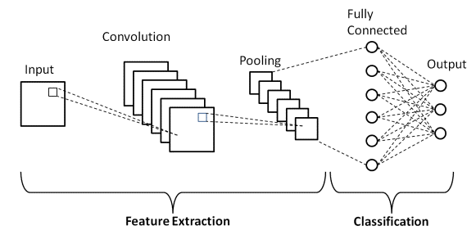

Figure 1: Basic structure of Convolutional neural network.

**2.1.2 Work related to convolutional neural network?**

Punam Patel et al. set a paper for fire/flame detection using cnn system. Image-based fire detection, it has been argued, necessitates a number of consecutive frames from the original video, which includes both fire and non-fire images. It is separated into three stages: identification of fire pixels using the RGB and YCb color models, detection of moving pixels, and examination of the shape of fire colored pixels in frames. This method is used to identify fire in video sequences[1]. Jareerat Seebamrungsat et al. proposed a study for fire detection utilizing a CNN image classification method. It was proposed to utilize the Color Segmentation method to separate fire from its backdrop. To distinguish the flame colors from the backdrop, the features of the HSV and YCbCr color models are applied. The HSV color model is used to identify color and brightness information. Then, for five consecutive frames, they determine the amount of white frames by dividing the difference between the preceding and actual frames [2]. Khan Muhammad et al. proposed an article titled effective deep CNN-based fire detection and localization in video surveillance systems. This method developed the intelligent feature map selection technique for selecting relevant feature maps from the learned CNN's convolutional layers that are sensitive to fire areas. When compared to previous handmade approaches, these feature maps allow for more precise fire segmentation. Using this, the model's size was decreased from 238 MB to 3 MB, lowering the cost and simplifying implementation. Another characteristic of this system is its capacity to recognize a burning object using a pre-trained model[3]. Abdulaziz, et.al., study for a fire detection belongs deep learning approach.In limited dataset for prevent overfiting problem, it can be suggested to a convolutional neural network and for fire and smoke images add new dataset to train and evaluate the model. Then it's can be improved training images as well as augmentation system.They gathered a new dataset consisting of fire and smoke photos that can be used to train and test the network, allowing the network to learn fire and smoke characteristics under diverse weather and light conditions[4]. Qingjie Zhang, et.al., set a paper which is forest fire detection using deep learning technique.They employ a tiny subset to design and test the method. Due to the short size of our annotated dataset, they studied two types of classifiers in this work: linear classifiers and non-linear classifiers. For our binary classification, they reduced the number of outputs in the final fully linked layer to two. They also decreased overfitting in this network, which is trained in just a few hundred iterations and achieves a surprisingly high training and testing accuracy[5]. Sebastien Frizzi1, et al., create an article in IEEE Transactions which is video fire and smoke detection using deep learning cnn technique. Their primary goal is to determine if a picture contains fire or smoke. They divided the photos into three subsets: training (60%), validation (20%), and test (20%). To enhance fire detection and localization on video, we must update our training set. The training data was generated using a computer equipped with an Intel Xeon microprocessor (frequency CPU 3,1 GHz, RAM 16 GB) and a graphic card GTX 980 Ti (2816 cores, 6 GB memory).

Furthermore, they compare the algorithm's classification accuracy on the test set to conventional approaches across a broader range of video fire pictures such as various materials, sources, and ventilations[6]. Muhammad Khan, [et.al](https://et.al)., set a paper which is fire detection using cnn techniques. A methodology is proposed that eliminates the time-consuming and difficult process of feature engineering by automatically learning rich characteristics from raw fire data. Several kernels of varying sizes are used to the input data to build feature maps in these. These feature maps are sent into the following step, known as subsampling or pooling, which selects the most activations from them within a narrow neighborhood. The purpose for such conception is to prevent unpredictable increases in computing complexity and network flexibility in dramatically increasing the number of units at each step. Furthermore, these methods enhance fire detection accuracy while minimizing false alarms, however the model size is fairly large at roughly 240 MB[7]. Sergio Saponara, Abdussalam Elhanashi & Alessio Gagliardi research about video fire/smoke detection using CNN techniques. It's specially using YOLOv2 algorithm for detect fire/smoke which is the one of algorithm of CNN. The author employed a vast scale of fire/smoke and negative movies in various situations, both inside and outdoor, in this case. The method takes the input picture and separates it into SXS grids for the proposed YOLOv2 approach, which used entire images to train and test the network. It extracts the grid's characteristics and predicts the bounding boxes as well as the confidence score for the discovered items in these boxes. The confidence score will be equal to the IoU value between the ground truth and the bounding boxes if there is an item. Otherwise, if there is no object, the confidence score will be 0.

**2.2 Fire detection and Neural network**

**2.2.1 Fire detection in Neural network**

Deep learning is a type of machine learning approach that mimics the physiology and activity of neurons in the neocortex. The design was inspired by the human brain, and it is capable of classifying photos, sounds, and texts straight from raw input. Convolutional neural networks (CNNs or ConvNet), a widely used deep learning architecture, have reached cutting-edge accuracy in object identification and recognition, as well as picture segmentation and classification. In this work, a supervised machine learning algorithm is employed to identify camera collected frames. When fire and non-fire portions coexist in a mixed picture, the frame is deemed to be fire-labeled, and when there is no fire in the frame, it is termed non-fire-labeled. It's a challenging work in image analysis of CNN. Traditional image processing algorithms used RGB channel comparison to distinguish distinct items in frames or films, such as fire. These classic approaches are not error-free and are not completely trustworthy [8]. For example, RGB value comparison algorithms that typically use a threshold value to identify fire may detect sunset and dawn as a false positive result.

**2.2.2 Popular CNN Achitecture**

Hubel and Wiesel identified the basic features of light detection of the cell receptive fields in the monkey cerebral cortex in 1968 [9]. Kunihiki Fukushima presented the NeoCognitron, a neural network model for visual pattern recognition, as a result of this study [10]. The NeoCognitron can be thought of as the forefather of current CNNs. Yan LeCun et al. developed the pioneering contemporary CNN architecture LeNet for handwritten digit recognition in 1990 [11]. LeNet was further enhanced to LeNet-5, which are multilayer convolutional networks trained using the back propagation technique. When a conventional CNN design won the ImageNet Large-Scale Visual Recognition Challenge (ILSVRC) in 2012, CNNs became extremely popular among researchers. Krizhevsky et al. introduced AlexNet, a breakthrough model comparable to LeNet-5 but with a deeper structure and the ability to handle millions of pictures [12]. Many studies have used AlexNet to effectively classify shots [13], remote sensing picture scene classification [14], computer-aided detection [15], parking lot occupancy detection [16], fingerprint detection [17], and fire detection. Many unique designs have been built as a result of the success of the AlexNet, including VGG, GoogleNet, ResNet, and Inception [18-21]. The new models are increasingly deeper and more powerful as CNNs evolve. For example, the ILSVRC winner in 2015, ResNet, has 152 layers, but AlexNet had only eight levels in 2012. ResNet research demonstrates the value of its use in visual recognition [22], as well as vehicle classification and localization [23]. Other CNN networks that are popular among academics include Densely connected network (DenseNet) [24], FractalNet [25], and Xception [26]. Girshick et al. [27] created R-CNN by combining region proposals with CNNs, which was effectively employed for object detection and semantic segmentation. The sluggish training procedure of RCNN was a noteworthy constraint, which Fast R-CNN [28] addressed while enhancing detection speed and quality. Similarly, Ren et al. [29] introduced Faster R-CNN, which may create more efficient and accurate region recommendations. The investigation of these three R-CNN models is a continuous topic among computer vision experts. R-CNN, Fast R-CNN, and Faster R-CNN have been utilized effectively in pedestrian detection [30-32], fire and smoke detection [33, 34], cell identification [35], face detection [36], and vehicle detection [37]. Other CNN networks that are popular among academics include Densely connected network (DenseNet) [38], FractalNet [39], and Xception [40]. Girshick et al. [41] created R-CNN by combining region proposals with CNNs, which was effectively employed for object detection and semantic segmentation. The sluggish training procedure of RCNN was a noteworthy constraint, which Fast R-CNN [42] addressed while enhancing detection speed and quality. Similarly, Ren et al. [43] presented Faster R-CNN, which may provide more efficient and accurate region recommendations. The investigation of these three R-CNN models is a continuous topic among computer vision experts. R-CNN, Fast R-CNN, and Faster R-CNN have all been utilized effectively in pedestrian detection [44-46], fire and smoke detection [47, 48], cell identification [49], face detection [50], and vehicle detection [51, 52].

These popular CNN architectures are mostly trained for probable object categories in the PASCAL VOC [53], IMAGENET [54], and MS COCO [55] benchmark datasets. However, the number of item categories in available benchmark datasets remains insufficient in contrast to the number of real-world objects recognized by people [46]. Among the things excluded from these popular benchmark datasets are fire and normal photos. It is obvious that CNN requires massive amounts of labeled data for training from start, which is computationally costly. These findings imply that one of the major obstacles in detecting fire and normal pictures is a lack of data sets, which might be solved through transfer learning.

**2.2.3 Transfer Learning Technique**

In deep learning approaches, transfer learning is a common and successful methodology. The idea behind transfer learning is to use pre-existing models as a starting point for training and transfer information from a comparable activity. In the case of transfer learning, fine-tuning a network is more easier and lot faster than starting from scratch. Early layers in the construction of CNNs contain general properties that may be re-used for a variety of applications. Otherwise last layer is the more application-specific. The first layers are well-preserved as a result of this feature, while the final ones are altered to train with the new dataset of interest [56, 57].

**2.2.4 CNN Based Fire Detection**

Several ways for enhancing the accuracy of smoke and fire detection using CNNs have recently been developed. To improve the performance of smoke detection, Yin et al. suggested a unique deep normalisation and convolutional neural network (DNCNN) inspired by ZFNet [58]. It was composed of fourteen layers, comprising eight normalisation and convolutional layers, three pooling layers, and three fully linked layers. DNCNN used data augmentation to boost the amount of training examples from the supplied limited dataset. There were 17,315 original photos and 25,533 enhanced images in the collection. Muhammad et al. developed a GoogleNet-inspired architecture for video-based fire detection that achieved an accuracy of 94.43 percent [59]. Aerial imaging pile burn detection using deep learning with flame dataset, on the other hand, comprises video recording and thermal heatmap acquired by cameras in the dataset. In this case, two machine learning tasks are used: (1) Exist or not exist fire flames in video frames for binary classification. An Artificial Neural Network (ANN) technique is created with a classification accuracy of 76%. (2) Fire detection by the use of segmentation approaches to properly define fire boundaries [60]. Our FLAME technique has an accuracy of 92 percent and a recall of 84%. The approach for free burning broadcast fire utilizing thermal pictures will be expanded in future study.

**Chapter 3**

**Data collection and preprocessing**

**3.1 Dataset for training and testing the CNN model**

We utilized many datasets from kaggle, many datasets from github, and many data personally acquired by camera for training and testing the CNN model. This collection is made up of RGB photos, with a total of 1000 images. We utilized around 500 photographs of fire, and 500 images are standard. We utilized 200 photos for testing and 800 images for training out of a total of 1000 images.

|  |  |  |
| --- | --- | --- |
| **Category** | **Train (Size)** | **Validation** |
| **Fire** | **500 images (7.31mb)** | **100 images** |
| **Normal** | **500 images(14.9mb)** | **100 images** |

Fig 1: Table of collected dataset.

**3.1 Dataset preparation**

Datasets are important in the performance of CNN because unbalanced training data has a detrimental influence on overall performance [61]. This section discusses the collection of picture dataset information. Deep learning has emerged as the preferred way for tackling a wide range of difficult issues. As we all know, with appropriate training, such deep networks can recognize the image's main elements. If a simple mechanism is large enough, it can have a magical effect. As a result, this well-functioning deep learning necessitates a large amount of data. The more training data there is, the greater the model's accuracy. This effort focused on creating a balanced dataset that included white, grey, black, and blue smoke, as well as yellow, orange, and reddish fire, for better training reasons. We also evaluated dense, light, sparse, and turbulent fire distributions in order to provide a balanced and demanding dataset. Furthermore, we have incorporated several sizes of fire and normal, ranging from a modest thin normal/fire to a catastrophic one. It is also worth noting that the dataset we created comprises many features such as clouds, trees, and normal/fire colored objects that might easily be mistaken with the properties of normal and fire.

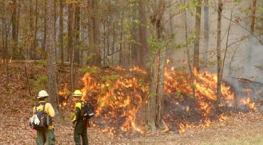 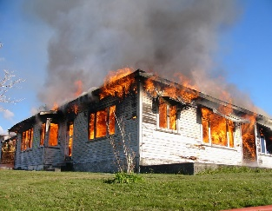 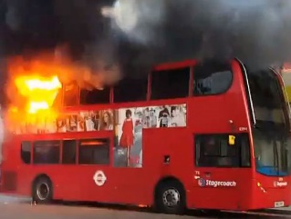 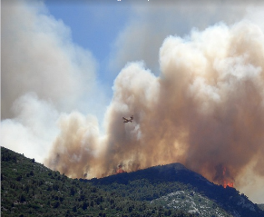

Fig 2: Sample images of fire images from the database.

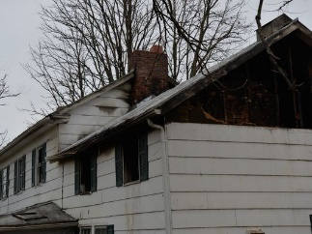  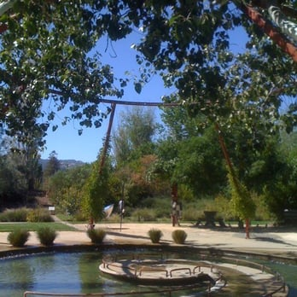 

Fig 3: Sample images of normal images from the database.

 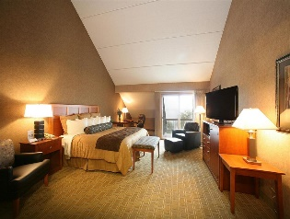  

Fig 4: Sample images of negative images from the database.

Sample frames from the dataset including normal, fire and negative images are shown in Figure 2,3, and 4. It should be mentioned here that, this dataset is essentially different from the dataset in terms of size and complexity.

**Chapter 4**

**Methodology**

**4.1 Convolutional layers**

We propose a network for integrated no fire and fire detection, inspired by CNN's recent success. The CNN model is created by borrowing some of the fundamental designs of the AlexNet [12] and then customizing the network with batch normalisation (BN) and parametric rectifier linear units (PReLU). We discuss our suggested model for no fire and fire detection in the following subsections. In addition, we describe how BN and PReLU are coupled to create a model. Convolutional layers are one of the primary components of Convolutional Neural Networks (CNNs). This layer's kernels or filters compute several feature maps. Each neuron in a feature map corresponds to a tiny area in the following layer. Convolving the input data with a kernel yields the new feature map. Mathematically, the feature map of the lth layer is given by:

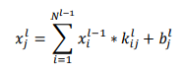

where 𝑥**** is the lth layer's output, 𝑥 is the previous layer's output, 𝑘 is the filter's kernel for the lth layer, and 𝑏 is the bias of the lth layer 𝑘 kernal is an abbreviation for shared by all of the input's spatial positions This sharing technique has the potential to minimize model complexity and make training the network easier. The suggested lightweight model is made up of five convolutional layers that are then batch normalized.

**4.2 Batch normalization layer (BN)**

This model employs a batch normalizing layer after each convolutional layer. The batch normalization layer's goal is to speed up network training while reducing sensitivity to parameter initialization. Ioffe et al. [62] emphasized the difficulties associated with training deep neural networks owing to internal covariate shift. Batch normalization, which normalizes each training mini-batch, was introduced to solve this issue. A non-linear activation function follows each BN. We use parametric rectifier linear units (PReLU) in this suggested model because of their human-level performance in picture categorization [63].

**4.3 Parametric Rectifier Linear Units (PReLU)**

The activation function is one of the deep learning model's innovative contributions since it endows deep networks with non-linear features. It has a substantial influence on the performance of deep neural networks. The Parametric Rectifier Linear Unit (PReLU) [64] is a popular activation function that has reached human-level performance in picture categorization and detection. It learns the parameters of the recitifiers adaptively from the input data. PReLU is a function that regulates the activation of the ReLU. When given a negative input, the ReLU function returns to zero. Because of its zero gradient characteristic, it may slow down training. They cannot learn using gradient-based approaches since the gradients are all 0. The comparison learning graph between ReLU and PReLU is depicted in Figure 5.

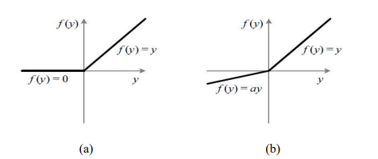

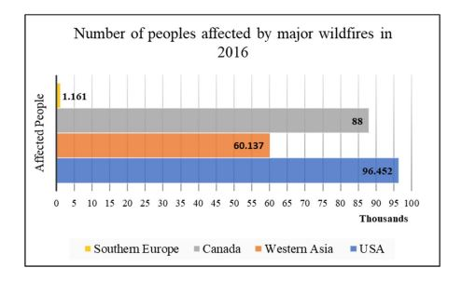

**Figure(1.1):** Number of people affected by major wildfire in 2006.[2]

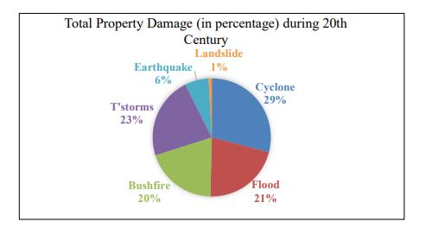

**Figure (1.2):** Total number of house losses due to natural hazard across

Australia during the 20th century [3]

**AIM AND OBJECTIVES**

The overall aim of this research is to devise a fire detection system using both conventional and deep learning techniques to ensure its capability of detection for complex outdoor environments as well as to develop a useful model inclusive of prediction and detection for RUI areas. The overall goal leads to the following primary objectives:

* Identify sets of features for detecting fire: Identifying and using a group of high discriminative and illumination insensitive local and global features for an effective smoke and fire detection technique.
* Utilise CNNs for fire detection: Exploring the state-of-the-art CNN models for fire detection and then comparing them with conventional hand-crafted feature based methods.
* Design a lightweight model: To develop a small lightweight CNN model by exploiting recent techniques of deep learning for combined fire detection.
* Formulate a fire safety model for RUI: A concept of exploiting meteorological data and machine learning algorithms in order to predict fire. This objective seeks to devise a novel fire monitoring system which will help to predict and detect fire.

**Motivation**

In today’s world, those responsible for life safety and property protection face a wide array of threats, dangers and emergencies – from fire and intrusions to violence and natural disasters. That’s true in all types of business, instructions and facilities, whether you work in the education, healthcare, government, commercial, hospitality or industrial sectors. In these highly challenging environment, safety and facilities organizations must be well prepared, equipped with appropriate fire and life-safety systems, and capable of communicating quickly and effectively in the event of an emergency.

While each individual life-safety system performs a specific function, one of the most effective ways to enhance to overall protection and gain other important benefits is through the integration of fire emergency communications security and life-safety systems.

**SCOPE OF RESEARCH**

This thesis mainly focuses on the fire detection using an image. For image based fire detection, one of the main challenges is to extract features as it largely varies in colour, shade, motion and density. A focus is mainly given to extract identifying descriptive features from the input image to detect fire. In particular, it mainly considers dynamic texture features and proposes a detailed experimental investigation of incorporating local and global features of the image.

The research also considers investigating the effectiveness of CNNs by utilising transfer learning and off-the-shelf features to the problem of fire detection. A focus is given to test the capacity of the recent state-of-the-art networks in the context of image based fire detection.

Additionally, this research aims to design a small lightweight model, inspired by any of the popular CNN models that can be applicable for combined fire detection. A guiding principle of this work is to consider the recent deep learning concepts of performance improvement applicable for fire detection.

For the overall fire monitoring system, this research aims to develop a fire safety model which integrates fire detection. This choice is motivated by the fact that machine learning algorithms can be effective techniques for detection.

All the code and data analysis presented in this thesis are conducted in the COLAB programming environment.

**THESIS OUTLINE**

Chapter 2 contains the Related Work, which discuss about CNN and previous work done in this field. It summarizes previously published papers.

In Chapter 3, we explain about our datasets. We describes about how to collect dataset (fire and normal) and how to preprocessing data.

Chapter 4, explain the proposed model, CNN layers and function, The CNN model and Fire detection algorithms.

In Chapter 5, we explain how we implement our propose model.

Chapter 6, Explain about discussion. In this field, we explain performance comparison

**Chapter 2**

**Related Work**

**2.1 What is CNN?**

CNN is a deep learning framework which is inspired from the mechanism of visual perception of living creatures. Since the first well-known DL architecture LeNet [10] for hand-written digits classification, it has shown promising results for combating different problems including action recognition [11], [12], pose estimation, image classification [13]–[14][15][16][17], visual saliency detection, object tracking, image segmentation, scene labeling, object localization, indexing and retrieval [18], [19], and speech processing. Among these application domains, CNNs have extensively been used in image classification, achieving encouraging classification accuracy over large-scale datasets compared to hand-engineered features based methods. The reason is their potential of learning rich features from raw data as well as classifier learning.

In convolution operation, several kernels of different sizes are applied on the input data to generate feature maps. These features maps are input to the next operation known as sub sampling or pooling where maximum activations are selected from them within small neighborhood. These operations are important for reducing the dimension of feature vectors and achieving translation invariance up to certain degree. Another important layer of the CNN pipeline is fully connected layer, where high-level abstractions are modeled from the input data. Among these three main operations, the convolution and fully connected layers contain neurons whose weights are learnt and adjusted for better representation of the input data during training process.

**2.2 Work Related to Fire Detection Using CNN**

In the literature, this time discusses the detection of fire in images using the Convolutional Neural Network (CNN) method. Because of the availability of many fire datasets on the internet, this literature prefers to use datasets by taking pictures from the internet.

This dataset consists of 651 images that are quite small in size but allow for the ability to test generalizability and effectiveness. This literature also tries to compare, among the available CNN architectures, and simple CNN [21]. The architecture to be compared is VGG16, Resnet50, and simple CNN. The results of VGG16 testing with 90.19%, Resnet50 with 91.18% and CNN only 50%. It can be concluded that to detect fire it is better to use deep convolutional neural networks. With 651 datasets and great accuracy for the VGG16 architecture with Resnet50, it signifies that the deeper the architecture, the more it can understand the features. Convolutional Neural Networks (CNN) is the development of Multilayer Perceptron (MLP) which is designed to process two-dimensional data. CNN was also used by Zhang [20] to detect forest fires, with excellent accuracy of 93.1%. CNN was first introduced by Fukushima [22] with hierarchical neural network architecture inspired by Hubel's research work [23]. Ciresan [24], uses CNN and gets the best performance for multiple object recognition from several image databases: MNIST, NORB, HWDB1.0, CIFAR10, and the ImageNet dataset**.**

In works [14] and [15], Deep CNN approach was taken to detection and localization of fires. The accuracy obtained was between 90 to 97% in both of these papers. This approach is time consuming and training was performed using Nvidia GTX Titan X with 12 GB of onboard memory.

Broadly speaking, CNN is not much different from the usual neural network. Convolutional Neural Network (CNN) is one type of neural network commonly used in image data. CNN is used to detect and recognize objects in an image. Convolutional Neural Network has 2 important blocks, namely Feature Learning and Classification. In the Feature Learning block, there are 2 layers, Convolution Layer, and Pooling Layer. In the Classification block there is one layer, namely Fully-Connected Layer.

**Chapter 3**

**Dataset**

**3.1 Data Collection**

In this section, we discuss collect of image dataset information. Deep learning has become the go to method for solving many challenging problems. As we know, for enough training those deep network identify the key points of the image. If a very simple mechanism is large enough, it will have a magical effect. Therefore, this well-functioning deep learning **requires a lot of data**. The more training data, the better the accuracy of the model.

In the deep learning era, **data is very well arguably your most valuable resource.** The image dataset for new algorithms is organised according to the WordNet hierarchy, in which each node of the hierarchy is depicted by hundreds and thousands of images. We are collected thousand of images. Some are collected from github repository and kaggle and some are manually captured from smart phone. And there are five hundred of images are fire. And five hundred of images are normal like house, roads, vehicle etc which have no fire.

|  |  |  |
| --- | --- | --- |
| **Category** | **Train** | **Validation** |
| **Fire** | **500 images (110mb)** | **100 images** |
| **Normal** | **500 images(100mb)** | **100 images** |

Our array of image classification datasets allows you to train computer vision models with one of the most comprehensive image datasets and deep learning image data.

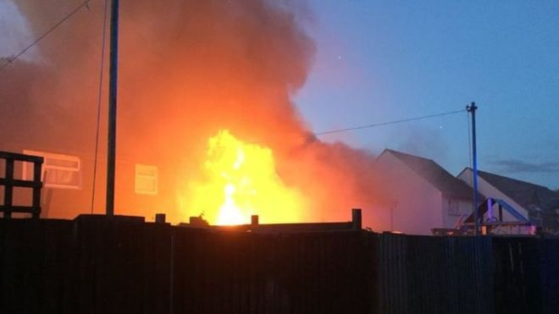 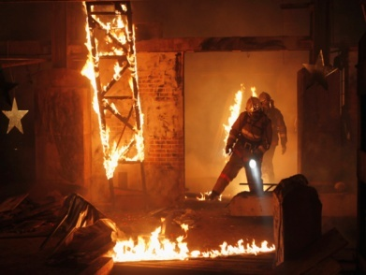 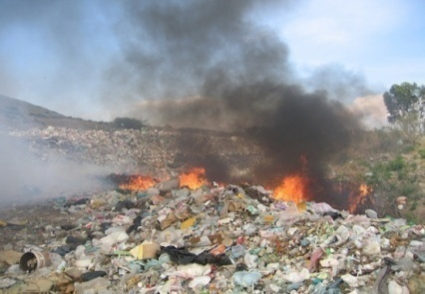

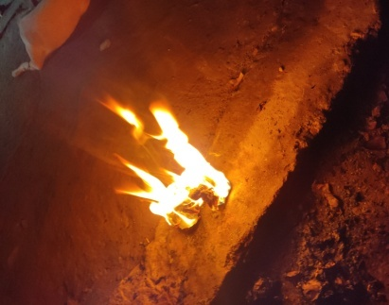 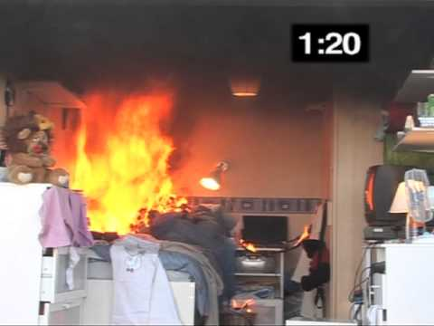 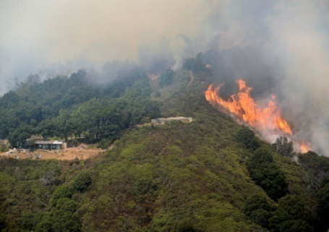

**  **

 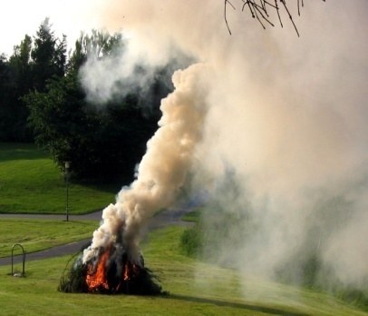 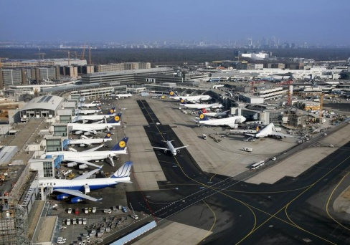

**Figures (3.1):** Sample of the Dataset

**3.2 Data Augmentation**

We used ImageDataGenerator from TensorFlow which allows us to perform image augmentation while the data is being fed into the models each epoch.

The images were resized to 150 x 150 pixels and augmented over a range of parameters showed a figure (3.2). Firstly all the images are normalized and then a random combination and range of augmentation are applied to each image. This process occurs every epoch producing varied training data each epoch with random augmentation each time. The primary reason to augment our dataset is to increase the size of the dataset, prevent overfitting and add variation.

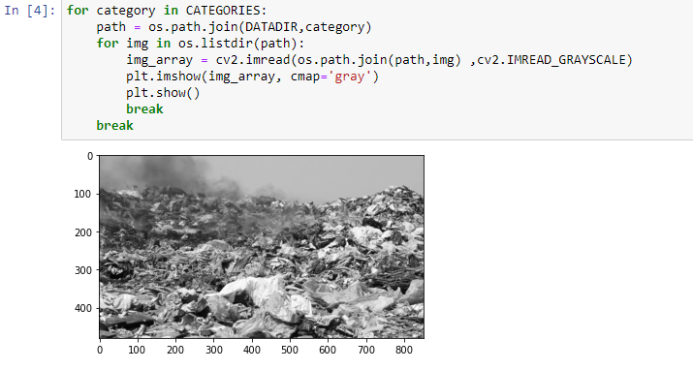

**Figures (3.2):** RGB to Gray Scale image conversion

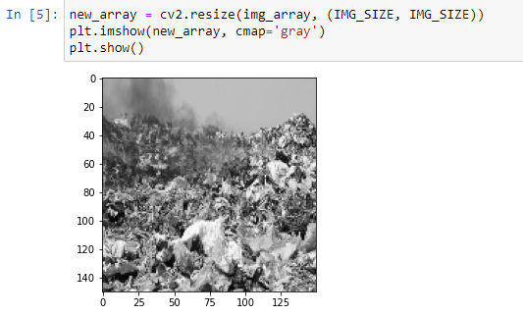

**Figures (3.2):** Resize image to 150 x 150

**Chapter 4**

**Methodology**

We wanted to create a fire detection model such that it would not allow users to upload any malicious content to the fire detection during the transaction process. To accomplish this we thought of combining Convolutional Neural Network with the fire detection architecture. We have used CNN to identify fire by visualizing files as grayscale images. The details of the models used are described in this chapter.

We have used Python Programming language (Python3) and create our CNN model. To set up the environment for the CNN model we have used the Keras library as well as scikit-learn library. For our CNN model, we have trained it for 10 epochs.

**4.1 Fire Detection Algorithm**

The proposed image based fire detection algorithm focuses on image based fire detection in the early sign of fire. A flowchart of the fire detection algorithm shown in figure 4.3

Input Image

Image Preprocessing

Feature Extraction

Using CNN

Classification with Sigmoid Function

**Figures (4.3):** Flowchart of the proposed fire detection using image

**Input Image**

**Image Preprocessing**

**Features Extraction using CNN**

Feature Extraction is the core part of in algorithms. Fire behaviors in using image processing approaches. These automatic imaged-based techniques are based on the features extracted from the input images. As a result, features play a crucial role in the development of fire detection techniques. In the feature extraction area, an extensive amount of research has considered the chaotic and unstable characteristics of fire in images. Existing feature extraction schemes are extensively reviewed in this section. Besides candidate region selection, colour is also utilised as an important element in the feature extraction step.

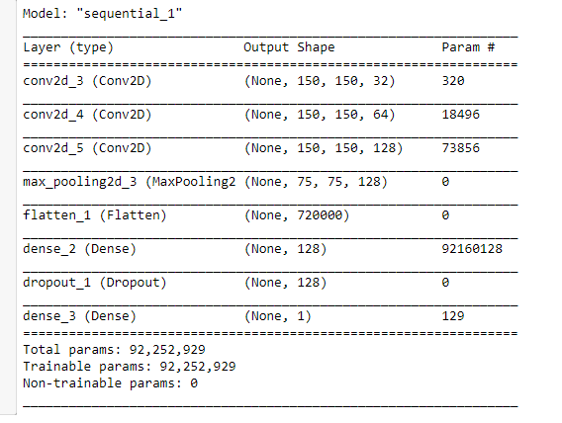

**Figure (4.2):** The Architecture of CNN Model

**Classification with Sigmoid Function**

**4.2 The CNN Model**

In our first model we have used five layers, namely three convolution layers and two dense layers. We divide the Fire dataset into 80 percent train set and 20 percent test set ratio. The input to the first convolution layer is a grayscale image of fixed size 150 x 150. In the first convolution layer we used 32 filters of 3 kernel size, the second layer of convolution we used 64 filter 3 kernel size and in the third layer of convolution we used 128 filters with default stride. Next, we used a pool size of 2 x 2 in the max pooling layers. Default strides are used for both convolution and max pooling layers. The first dropout layer drops 25 percent neurons whereas the second dropout layer drops 50 percent of the neurons. 128 neurons are applied in the first dense layer and for the second dense layer 50 neurons are used. The two convolutions and dense layers use the ReLU activation function. However, the last dense layer uses the sigmoid activation function to classify whether an image belongs to any of the Fire classes or not. We have used the cross entropy loss function with Adam optimizer.

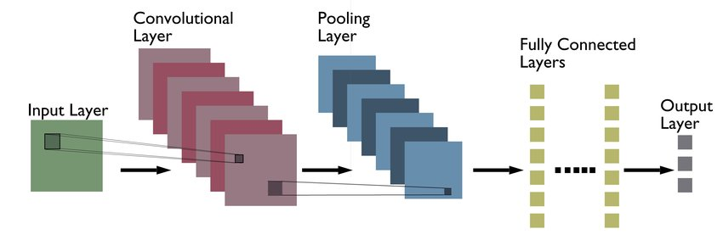

**Figure (4.2):** The Architecture of CNN Model

**4.3 CNN Layers and Function**

**4.3.1 Convulational Layer**

In the convolutional layer, one matrix comprises a set of learnable parameters called kernel, and the other matrix acts as the restricted portion of the receptive field and the output is dot product of these matrices. Despite the size of the kernel being smaller than an image, it allows a more in depth sparse interaction. The dimensions generated by the kernel are proportional to the height and width of the image. This two-dimensional representation, referred to as an activation or map of features, provides the response of the kernels for each spatial location of the image, and the sliding size is referred to as the kernel stride [28]. Padding is used when the filter does not fit the input image perfectly and we want to avoid losing pixels on the perimeter of the image for which the extra pixels are generally set to 0 [29].

**4.3.2 Pooling Layer**

Pooling layers serve the purpose of reducing the sensitivity of convolutional layers to location and of spatially down sampling the representation [30]. While pooling down samples the image in terms of height and width, the number of channels (depth) remains the same [31]. There are different kinds of spatial pooling functions such as max pooling, average pooling and sum pooling. We have used max pooling which works with the largest component from the rectified feature map [32].

**4.3.3 Dropout Layer**

To avoid a model from overfitting, dropout layers are used which operate by randomly setting the outgoing edges of hidden units (neurons that make up hidden layers) to 0 at each training phase change [33].

**4.3.4 Flatten Layer**

To transform the data into a one dimensional array as input for the fully connected layer, we use the flatten layer. A single long feature vector is the result of flattening the output of the previous layers [34].

**4.3.5 Fully Connected Layer**

Fully connected layers are feed forward neural networks where all the neurons are fully connected to all the neurons in the preceding and subsequent layers [31], [28].

**4.3.6 ReLU Activation Function**

Rectified linear activation function is a piecewise linear function which provides the activation sum input with more sensitivity and prevents fast saturation. The activation function used by rectified linear units is g(z) = max{0, z}. Since rectified linear units are nearly linear, they retain many of the properties of linear activation functions which allow for easier optimization with gradient-based methods and generalisation while acting as a nonlinear function which always outputs negative values as 0. Usage of ReLU activation function in hidden layers improves the overall performance of the network [34], [35].

**4.3.7 Sigmoid Function**

The sigmoid function is used for the two-class (binary) classification. The input to the function is translated to a value between 0 and 1. This property makes sigmoid activation function be useful when used in the output layer of the network for predicting the probability as an output. This property of the sigmoid function makes it a great candidate to be used in our CNN models [36], [35].

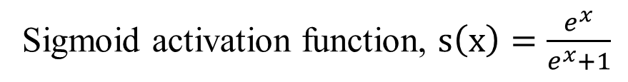

**4.3.8 Cross entropy Loss Function**

Loss functions are used to minimize errors in the network during the training process. To measure the performance of a model whose output is a probability value between 0 and 1, cross-entropy loss, or log loss is used [37], [38].

**Chapter 5**

**Implemental Result Analysis**

**5.1 Machine Specification for Implementation:**

For implementing and testing all the model, we used,

* CPU: Intel core i3 1.8ghz
* GPU: AMD Radion 2 GB
* RAM: 4GB

**5.2 File Conversation:**

* To covert the user files into grayscales images, we first read the binary file as raw binary input.
* Then the length of the data is put in a numpy array. The data is converted to a vector and the data length array is taken in to be the shape of a square which is then padded with zeros.
* Next, we reshape the arrays with the squared padded length. Using the OpenCV library, we convert it to an image to be processed by the CNN model.

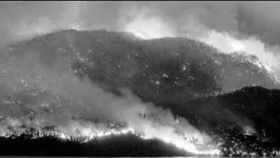

**Figure (5.3):** Any File conversation to grayscale.

**5.3 Used Tool:**

**Platform:**

Google COLAB

**Programming Language:**

Python Language

**Libraries:**

OpenCV:

TensorFlow:

Numpy:

Matplotlib:

**API:** Keras

**5.5 Results**

For training and testing the custom CNN model it took approximately 1 hour to run 10 epochs. When this model was saved to be loaded from the python script it had a total size of 4.5 megabytes. After training and testing the models, the custom CNN model had an accuracy of 98%.

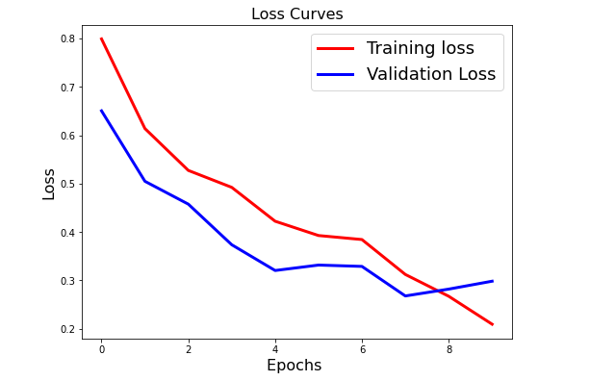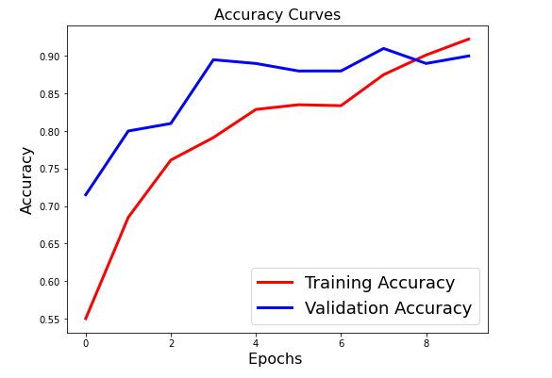

**Figures (5.5):** ModelAccuracy and Loss curve of CNN Model

**Performance Matrix**

**Precision**

Precision: is also known as positive predictive value. It is the ratio of correctly predicted positive observation to the total positive observations. It can be computed by dividing the true positive observations by the sum of true positives and false positives.

Precision =

true positives

(true positives + false positives)

**Recall**

Recall: is also known as sensitivity. It is the ratio of our model where it correctly identifies the positive observations. It can be computed by dividing the true positive observations by the sum of true positives and false negatives.

Recall =

true positives

(true positives + false negatives)

**Confusion Matrix:**

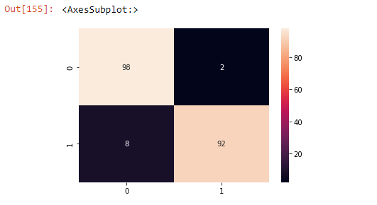

|  |  |  |  |  |
| --- | --- | --- | --- | --- |
| **Epoch** | **Model** | **Precision (%)** | **Recall** | **F1-Score (%)** |
| 10 | CNN | 92.31 | 97.96 | 94.43 |

**Correctly Classify Fire Image**

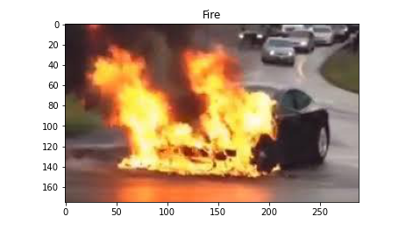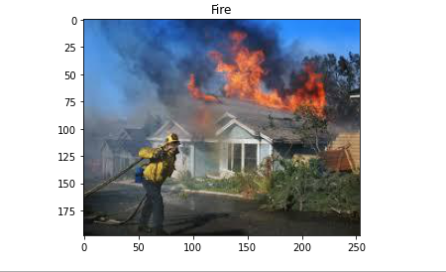

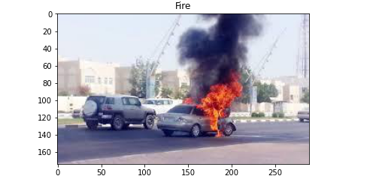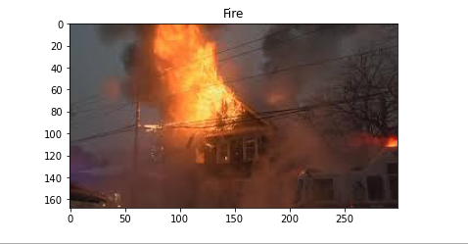

**Correctly Classify No-Fire Image**

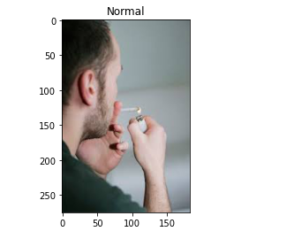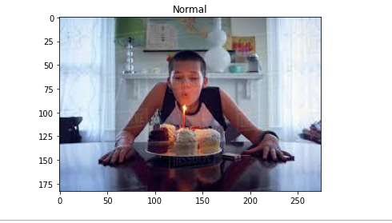

**5.7 Comparison Performance:**

While In [39] the author opt-out of the binary classification (fire and no fire) and achieved a performance of accuracy of 92%, our model classifying with fire and no fire, and we achieved an accuracy of 98%. Our experiment is different from their approach in terms of the classes and classifiers, wherein they implemented CNN, Inception v3. They used 240 images for fire and get an accuracy of 92% whereas we used 500 images for fire.

In [40] DNCNN (Deep normalization and convolutional neural network), traditional convolutional layers are replaced with normalization and convolutional layers to accelerate the training process and boost the performance of smoke detection. To reduce overfitting caused by imbalanced datasets and insufficient training data sets by using a variety of data enhancement techniques. Their model showed an accuracy of 96.93% based on the smoke dataset, while ours had an accuracy of 98%.

In another related study, the authors of [41] proposed a CNN model of Faster-R-CNN, R-FCN, SSD, and YOLO v3. The Model achieved the highest accuracy of 83.7% based on YOLO v3, while our model achieved an accuracy of 98%.

In [42] author proposed based on transfer learning and evaluation of state-of-the-art VGG16 and deep convolutional neural networks for fire image classification from fire images. The author used Adam optimizers with the VGG16 architecture with 300 and 500 epochs tend to steadily improve their accuracy and achieve 96%. Where we used Adam optimizers with the CNN architecture with 10 epochs and achieved 98%.

**Chapter 8**

**Conclusion and Future Challenge**

When present, humans can be excellent fire detectors. The healthy person is able to sense multiple aspects of a fire including the heat, flames, smoke, and odors. For this reason, most fire alarm systems are designed with one or more manual alarm activation devices to be used by the person who discovers a fire. Unfortunately, a person can also be an unreliable detection method since they may not be present when a fire starts, may not raise an alarm in an effective manner, or may not be in perfect heath to recognize fire signatures. It is for this reason that a variety of automatic fire detectors have been developed. Automatic detectors are meant to imitate one or more of the human senses of touch, smell or sight. Thermal detectors are similar to our ability to identify high temperatures, smoke detectors replicate the sense of smell, and flame detectors are electronic eyes. The properly selected and installed automatic detector can be a highly reliable fire sensor.

Manual fire detection is the oldest method of detection. In the simplest form, a person yelling can provide fire warning. In buildings, however, a person's voice may not always transmit throughout the structure. For this reason, manual alarm stations are installed. The general design philosophy is to place stations within reach along paths of escape. It is for this reason that they can usually be found near exit doors in corridors and large rooms.

The advantage of manual alarm stations is that, upon discovering the fire, they provide occupants with a readily identifiable means to activate the building fire alarm system. The alarm system can then serve in lieu of the shouting person's voice. They are simple devices, and can be highly reliable when the building is occupied. The key disadvantage of manual stations is that they will not work when the building is unoccupied. They may also be used for malicious alarm activations. Nonetheless, they are an important component in any fire alarm system.

Thermal detectors are the oldest type of automatic detection device, having origin in the mid 1800's, with several styles still in production today. The most common units are fixed temperature devices that operate when the room reaches a predetermined temperature (usually in the 135°–165°F/57°–74°C). The second most common type of thermal sensor is the rate-of-rise detector, which identifies an abnormally fast temperature climb over a short time period. Both of these units are "spot type" detectors, which means that they are periodically spaced along a ceiling or high on a wall. The third detector type is the fixed temperature line type detector, which consists of two cables and an insulated sheathing that is designed to breakdown when exposed to heat. The advantage of line type over spot detection is that thermal sensing density can be increased at lower cost.

Thermal detectors are highly reliable and have good resistance to operation from nonhostile sources. They are also very easy and inexpensive to maintain. On the down side, they do not function until room temperatures have reached a substantial temperature, at which point the fire is well underway and damage is growing exponentially. Subsequently, thermal detectors are usually not permitted in life safety applications. They are also not recommended in locations

where there is a desire to identify a fire before substantial flames occur, such as spaces where high value thermal sensitive contents are housed.

Smoke detectors are a much newer technology, having gained wide usage during the 1970's and 1980's in residential and life safety applications. As the name implies, these devices are designed to identify a fire while in its smoldering or early flame stages, replicating the human sense of smell. The most common smoke detectors are spot type units, that are placed along ceilings or high on walls in a manner similar to spot thermal units. They operate on either an ionization or photoelectric principle, with each type having advantages in different applications. For large open spaces such as galleries and atria, a frequently used smoke detector is a projected beam unit. This detector consists of two components, a light transmitter and a receiver, that are mounted at some distance (up to 300 ft/100m) apart. As smoke migrates between the two components, the transmitted light beam becomes obstructed and the receiver is no longer able to see the full beam intensity. This is interpreted as a smoke condition, and the alarm activation signal is transmitted to the fire alarm panel.

A third type of smoke detector, which has become widely used in extremely sensitive applications, is the air aspirating system. This device consists of two main components: a cotrol unit that houses the detection chamber, an aspiration fan and operation circuitry; and a network of sampling tubes or pipes. Along the pipes are a series of ports that are designed to permit air to enter the tubes and be transported to the detector. Under normal conditions, the detector constantly draws an air sample into the detection chamber, via the pipe network. The sample is analyzed for the existence of smoke, and then returned to atmosphere. If smoke becomes present in the sample, it is detected and an alarm signal is transmitted to the main fire alarm control panel. Air aspirating detectors are extremely sensitive and are typically the fastest responding automatic detection method. Many high technology organizations, such as telephone companies, have standardized on aspiration systems. In cultural properties they are used for areas such as collections storage vaults and highly valuable rooms. These are also frequently used in aesthetically sensitive applications since components are often easier to conceal, when compared to other detection methods.

The key advantage of smoke detectors is their ability to identify a fire while it is still in its incipient. As such, they provide added opportunity for emergency personnel to respond and control the developing fire before severe damage occurs. They are usually the preferred detection method in life safety and high content value applications. The disadvantage of smoke detectors is that they are usually more expensive to install, when compared to thermal sensors, and are more resistant to inadvertent alarms. However, when properly selected and designed, they can be highly reliable with a very low probability of false alarm.

Flame detectors represent the third major type of automatic detection method, and imitate the human sense of sight. They are line of sight devices that operate on either an infrared, ultraviolet or combination principle. As radiant energy in the approximate 4,000 to 7,700 angstroms range occurs, as indicative of a flaming condition, their sensing equipment recognizes the fire signature and sends a signal to the fire alarm panel.

The advantage of flame detection is that it is extremely reliable in a hostile environment. They are usually used in high value energy and transportation applications where other detectors would be subject to spurious activation. Common uses include locomotive and aircraft maintenance facilities, refineries and fuel loading platforms, and mines. A disadvantage is that they can be very expensive and labor intensive to maintain. Flame detectors must be looking directly at the fire source, unlike thermal and smoke detectors which can identify migrating fire signatures. Their use in cultural properties is extremely limited.

**Alarm Output Devices**

Upon receiving an alarm notification, the fire alarm control panel must now tell someone that an emergency is underway. This is the primary function of the alarm output aspect of a system. Occupant signaling components include various audible and visual alerting components, and are the primary alarm output devices. Bells are the most common and familiar alarm sounding device, and are appropriate for most building applications. Horns are another option, and are especially well suited to areas where a loud signal is needed such as library stacks, and architecturally sensitive buildings where devices need partial concealment. Chimes may be used where a soft alarm tone is preferred, such as health care facilities and theaters. Speakers are the fourth alarm sounding option, which sound a reproducible signal such as a recorded voice message. They are often ideally suited for large, multistory or other similar buildings where phased evacuation is preferred. Speakers also offer the added flexibility of emergency public address announcements. With respect to visual alert, there are a number of strobe and flashing light devices. Visual alerting is required in spaces where ambient noise levels are high enough to preclude hearing sounding equipment, and where hearing impaired occupants may be found. Standards such as the Americans with Disabilities Act (ADA) mandate visual devices in numerous museum, library, and historic building applications.

Another key function of the output function is emergency response notification. The most common arrangement is an automatic telephone or radio signal that is communicated to a constantly staffed monitoring center. Upon receiving the alert, the center will then contact the appropriate fire department, providing information about the location of alarm. In some instances, the monitoring station may be the police or fire departments, or a 911 center. In other instances it will be a private monitoring company that is under contract to the organization. In many cultural properties, the building's inhouse security service may serve as the monitoring center.

Other output functions include shutting down electrical equipment such as computers, shutting off air handling fans to prevent smoke migration, and shutting down operations such as chemical movement through piping in the alarmed area. They may also activate fans to extract smoke, which is a common function in large atria spaces. These systems can also activate discharge of gaseous fire extinguishing systems, or preaction sprinkler systems.

**Sensor-Assisted Fire Fighting**

The way firefighters put out fires in a burning building changes once there are smart sensors installed inside. Connected to the internet, these sensors allow firefighters to get a live feed into the progress of the fire, thereby helping them strategize the best way to handle the situation. Using building schematics and rendered computer models from the sensor technology, firefighters are much more prepared to act effectively and safely.

**High-Pressure Water Mist:**

A significant apprehension that consumers have towards commercial fire systems is having a thousand gallons of water spewed all over their electronics. Although water is one of the most effective agents in fighting fires, it can cause a lot of damage to the buildings, often rendering it unusable after it has done its job. High-pressure mist effectively blocks radiant heat and oxygen from reaching the fire, effectively isolating problem areas while protecting others.

**Drones**

Teams in the USA and even Australia are deploying drones that help firefighters identify hotspots by sending them real-time data, including images and video. Other drone models are used to provide aerial vision, among other things, to those directing the firefighting process. Providing unique insight to those who would typically require expensive helicopters to do the same work. Better yet, more advanced, and expensive, drones are being developed to fly up to 900 feet to spray water that would be typically unreachable by truck-mounted ladders.

**Fireballs**

Although their name suggests the opposite of what they do,fireballs actually take the place of a traditional fire extinguisher, covering more space and doing it much faster. If you don’t believe it, you should check out the video in the link. Created by a company called Elide, the fireball can even fight fires when a user cannot be present to use it. As their website states, “When a fire occurs and no one is present, Fire Extinguishing Ball will self-activate when it comes into contact with fire and give a loud noise as a fire alarm. Because of this feature, it can be placed in a fire prone area such as near an electrical circuit breaker or in a kitchen.”

**Wireless Devices**

Perhaps most applicable to dealers looking to grow their RMR, wireless devices provide mobile capabilities to homeowners looking to install themselves, or even to take with them when relocating. According to firesystemsltd.co.uk, “Some of the systems on the market are using mesh network for the first time in wireless fire detection technology. The detectors are connected to each other and are using different frequencies on different bandwidths.” For those who look for something truly reliable in any situation, many devices can be connected in wired and non-wired formats. This dual connectivity provides unprecedented coverage and ultimate reliability. Yet, for buildings that are difficult to wire, or consumers who want something simple, wire-free systems will take the market by storm.

**Sound-Triggered Devices:**

An effective way to monitor non-monitored fire-alarms is by using a sound-triggered device like those made by Nest or Le0o. These devices plug into the wall for endless energy connection and wait for the fire alarm to go off. Once the sound is emitted, the device triggers a notification to a

**6.2 Limitation:**

We have faced numerous limitations while conducting our research. First and foremost, due to current circumstances, we did not have access to the Thesis Lab of East Delta University which would have provided us with the higher computational power required for the implementation of our thesis. For the testing and training process of our CNN models, we had to implement and run sophisticated machine learning algorithms using very limited resources. We especially struggled during the CNN model training and testing process because it required maximum CPU usage, with each epoch taking quite a lot of time to finish. Moreover, after a certain number of epochs we faced kernel and system crashes. This limited us in the sense that we could not test the CNN models under different research conditions, for example, increasing the epoch, steps per epoch etc

**Reference**

[1] "Fire & Rescue NSW." https://www.fire.nsw.gov.au (accessed 05/10/2018).

[2] D. Guha-Sapir, P. Hoyois, P. Wallemacq, and R. Below, "Annual Disaster Statistical Review 2016: The Numbers and Trends," Centre for Research on the Epidemiology of Disasters (CRED),Brussels, Belgium, 2016. [Online]. Available: <http://www.cred.be/sites/default/files/ADSR_2016.pdf>

[3]

[4]

[5]

[6]

[7]

[8]

[9]

[10] Y. Le Cun et al, Proc. Adv. Neural Inf. Process., "Handwritten digit recognition with a back-propagation network", Syst., pp. 396-404, 1990.

[11] A. Ullah, J. Ahmad, K. Muhammad, M. Sajjad and S. W. Baik, "Action recognition in video sequences using deep Bi-directional LSTM with CNN features", IEEE Access, vol. 6, pp. 1155-1166, 2017.

[12] A. Ullah et al, J. Korean Inst. Next Generation., "Action recognition in movie scenes using deep features of keyframes", Comput., vol. 13, pp. 7-14, 2017.

[13] L. Shao, L. Liu and X. Li.,"Feature learning for image classification via multi objective genetic programming", IEEE Trans. Neural Netw. Learn. Syst., vol. 25, no. 7, pp. 1359-1371, Jul. 2014.

[14] F. Li, L. Tran, K. H. Thung, S. Ji, D. Shen and J. Li, "A robust deep model for improved classification of AD/MCI patients", IEEE J. Biomed. Health Inform., vol. 19, no. 5, pp. 1610-1616, Sep. 2015.

[15] R. Zhang, J. Shen, F. Wei, X. Li and A. K. Sangaiah, Artif. Intell. Med., "Medical image classification based on multi-scale non-negative sparse coding", vol. 83, pp. 44-51, Nov. 2017.

[16] O. W. Samuel et al., "Pattern recognition of electromyography signals based on novel time domain features for amputees’ limb motion classification", Comput. Elect. Eng., [online] Available: <https://doi.org/10.1016/j.compeleceng.2017.04.003>.

[17] Y.-D. Zhang et al., "Image based fruit category classification by 13-layer deep convolutional neural network and data augmentation", Multimedia Tools Appl., pp. 1-20, Sep. 2017, [online] Available: <https://link.springer.com/article/10.1007/s11042-017-5243-3>.

[18]J. Yang, B. Jiang, B. Li, K. Tian and Z. Lv, "A fast image retrieval method designed for network big data", IEEE Trans. Ind. Inform., vol. 13, no. 5, pp. 2350-2359, Oct. 2017.

[19] J. Ahmad, K. Muhammad and S. W. Baik, "Data augmentation-assisted deep learning of hand-drawn partially colored sketches for visual search", PLOS ONE, vol. 12, no. 8, pp. e0183838, 2017.

[20] Zhang, Q., Xu, J., Xu, L., Guo, H.:, “Deep convolutional neural networks for forest fire detection”, February 2016.

[21] Frizzi, S., Kaabi, R., Bouchouicha, M., Ginoux, J., Moreau, E., Fnaiech, F., “Convolutional Neural Network for Video Fire and Smoke Detection”, 2016.

[22] Fukushima, K.: Neocognitron:, “a self-organizing neural network model for a mechanism of pattern recognition unaffected by shift in position”, 1980.

[23] Hubel, D, H., Wiesel, T, N., “Ferrier lecture: Functional architecture of macaque monkey visual cortex”, 1977.

[24] D. Ciresan, U. Meier; J. Masci; L.M. Gambardella and J. Schmidhuber, “Flexible, High Performance Convolutional Neural Networks for Image Classification”, November 2013

[25] [Zhang, Qingjie & Xu, Jiaolong & Xu, Liang & Guo, Haifeng.,“Deep Convolutional Neural Networks for Forest Fire Detection” (2016).

[26] K. Muhammad, J. Ahmad, Z. Lv, P. Bellavista, P. Yang and S. W. Baik, “Efficient Deep CNN-Based Fire Detection and Localization in Video Surveillance Applications,” in IEEE Transactions on Systems, Man, and Cybernetics: Systems, vol. 49, no. 7, pp. 1419-1434, July 2019.

[28] M. Mishra., “Convolutional neural networks, explained”, (2020 (accessed: January 6, 2021)). [Online]. Available: https : / / towardsdatascience . com / convolutional-neural-networks-explained-9cc5188c4939#:∼:text=Convolutional% 5C%20Neural%5C%20Network%5C%20Architecture, and%5C%20a%5C% 20fully%5C%20connected%5C%20layer.

[29] A. Zhang, Z. C. Lipton, L. Mu, and A. J. Smola.,“Padding and stride”, ((accessed: January 6, 2021)). [Online]. Available: http : / / d2l . ai / chapter convolutional-neural-networks/padding-and-strides.html#stride

[30] ——, ((accessed: January 6, 2021)). “Pooling,” [Online]. Available: http:// d2l.ai/chapter convolutional-neural-networks/pooling.html.

[31] Arunava. (2018 (accessed: January 6, 2021)). “Convolutional neural network: An introduction to convolutional neural networks,” [Online]. Available: https: //towardsdatascience.com/convolutional- neural- network-17fb77e76c05#: ∼: text=Fully%5C%20Connected%5C%20Layer%5C%20is%5C%20simply,into% 5C%20the%5C%20fully%5C%20connected%5C%20layer.

[32] Prabhu., “Understanding of convolutional neural network (cnn) — deep learning”, (2018(accessed: January 6, 2021)). [Online]. Available: https://medium. com/@RaghavPrabhu/understanding-of-convolutional-neural-network-cnndeep-learning-99760835f148

[33] C. Maklin. “Dropout neural network layer in keras explained”, (2019 (accessed: January 6, 2021)). [Online]. Available: https: / / towardsdatascience. com / machine-learning-part-20-dropout-keras-layers-explained-8c9f6dc4c9ab#:∼: text=Dropout%5C%20is%5C%20a%5C%20technique%5C%20used,update% 5C%20of%5C%20the%5C%20training%5C%20phase.

[34] J. Jeong., “The most intuitive and easiest guide for convolutional neural network”, (2019 (accessed: January 6, 2021)). [Online]. Available: https : / / towardsdatascience.com/the-most-intuitive-and-easiest-guide-for-convolutionalneural-network-3607be47480.

[35] I. Goodfellow, Y. Bengio, and A. Courville, “Deep Learning”, MIT Press, 2016, <http://www.deeplearningbook.org>.

[36] J. Brownlee.,“A gentle introduction to the rectified linear unit (relu)”, (2020 (accessed: January 6, 2021)). [Online]. Available: https://machinelearningmastery. com/rectified-linear-activation-function-for-deep-learning-neural-networks/ #: ∼ : text = The% 5C% 20rectified% 5C% 20linear% 5C% 20activation% 5C% 20function , otherwise % 5C % 2C % 5C % 20it % 5C % 20will % 5C % 20output % 5C%20zero.&text=The%5C%20rectified%5C%20linear%5C%20activation% 5C % 20function % 5C % 20overcomes % 5C % 20the % 5C % 20vanishing % 5C % 20gradient%5C%20problem,learn%5C%20faster%5C%20and%5C%20perform% 5C%20better.

[37] S. Sharma., “Activation functions in neural networks”, (2017(accessed: January 6, 2021)). [Online]. Available: https://towardsdatascience.com/activationfunctions-neural-networks-1cbd9f8d91d6.

[38] M. Glossary.,“Loss functions,” (2017(accessed: January 6, 2021)). [Online]. Available: https://ml - cheatsheet. readthedocs.io/en/latest/loss functions. html.

[40]Raam Pujangga Sadewa , Budhi Irawan, Casi Setianingsih School of Electrical Engineering Telkom University Bandung, Indonesia raamps@student.telkomuniversity.ac.id, budhiirawan@telkomuniversity.ac.id, [setiacasie@telkomuniversity.ac.id](mailto:setiacasie@telkomuniversity.ac.id)

[41] Z. Yin, B. Wan, F. Yuan, et al., “A deep normalization and convolutional neural network for image smoke detection”, IEEE ACCESS, vol. 5, pp.18429–18438, 2017.

[42] Pu Li a,b,* , Wangda Zhao a a School of Civil Engineering, Central South University, Changsha, 410075, Hunan, China b Zhengzhou Airport Economy Zone Fire Brigade, Zhengzhou, 450000, China

[43] Fofana, T. , Ouattara, S. and Clement, A., “Optimal Flame Detection of Fires in Videos Based on Deep Learning and the Use of Various Optimizers”, Vol.11 No.11, November 2021.